**Data Structures and Algorithms**

**Lab report: 5**

|  |  |
| --- | --- |
| **Name:** | **Ali Salman** |
| **Reg no:** | **FA22-BCE-005** |
| **Class:** | **BCE-3A** |
| **Lab Instructor:** | **Dr. Ali Mustafa** |

**Lab 05**

**Stack Implementation with Applications**

**In-lab Task 1:**

**Reversing an array of numbers.**

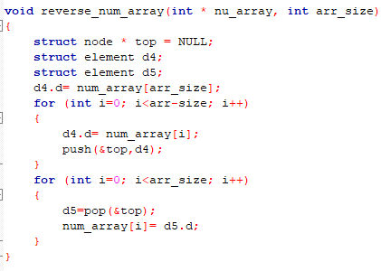

**In-Lab Task 2:**

**Testing if a mathematical expression is balanced or not.**

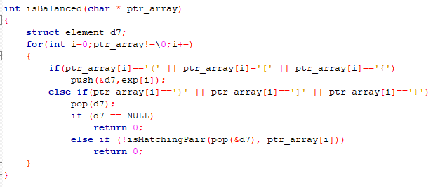

**Post-Lab Task:**

**Infix to postfix conversion**

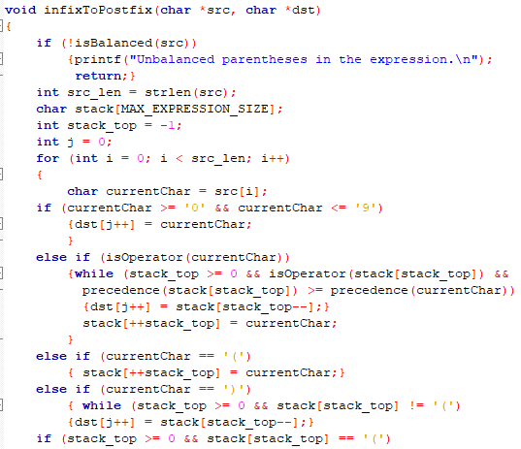

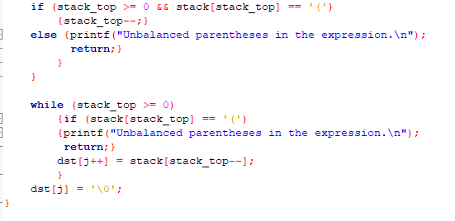

**Critical Analysis:**

Reversing an array is a straightforward problem that allows students to implement a stack, push elements onto it, and then pop them in reverse order to achieve the desired outcome. This task serves as a great introductory exercise, helping students consolidate their understanding of stacks and linked lists.

Testing for balanced mathematical expressions is a classic problem that is elegantly solved using stacks. This task reinforces the concept of stacks and their utility in solving practical problems. Additionally, it cultivates skills in error checking and ensuring correctness, which are crucial skills for future programmers.

Converting infix expressions to postfix notation is a more complex task. It takes students to a higher level of understanding by introducing them to an essential concept in computer science and programming. This task not only consolidates their knowledge of stacks but also enhances their problem-solving skills.